**Name: Abu Bakar Rasheed**

**Roll no: l1f23bsse0371**

**Submit to: Mam Roha Irfan**

**Lab:9**

**Submit on: 26 May**

**__________________________________**

**Q:1**

select firstName,lastName

from employees

where officeCode in

(select officeCode

from offices

where country="USA");

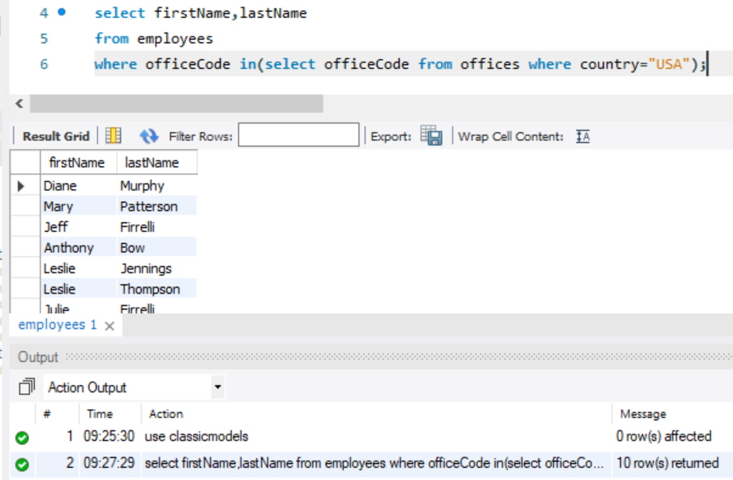

**Q:2**

select *

from customers

where customerNumber in

(select customerNumber

from payments

where amount >1000 and amount <5000 );

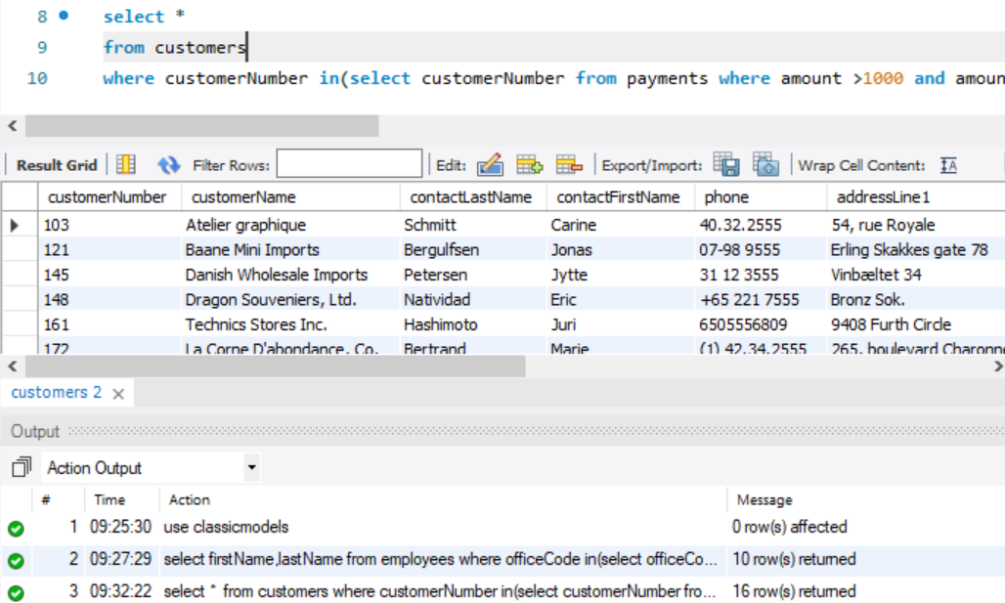

**Q:3**

select customerName,phone

from customers

where customerNumber in

(select customerNumber

from orders

where year(orderDate)=2003 and year(shippedDate)=2003);

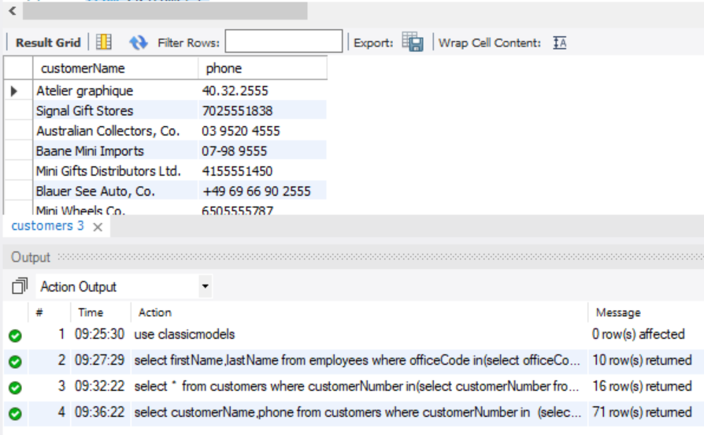

**Q:4**

select *

from customers

where customerNumber not in(select customerNumber from orders);

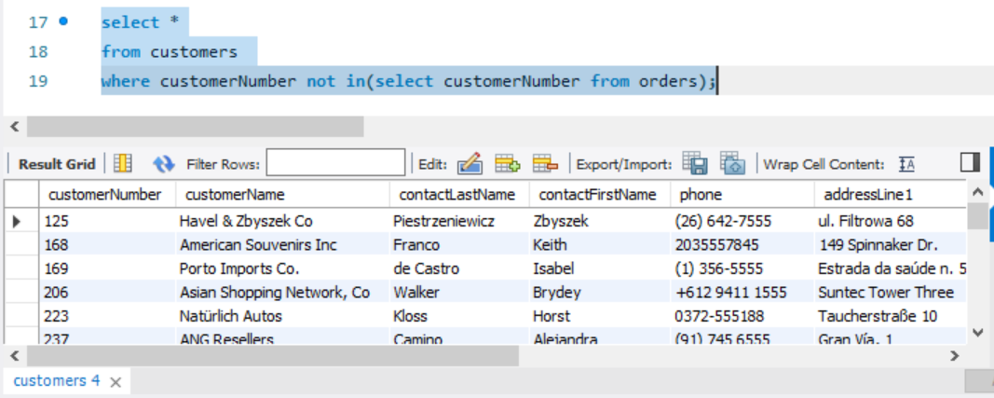

**Q:5**

select productName, productCode

from products

where productCode in

(select productCode from orderdetails where quantityOrdered >30 and quantityOrdered<50);

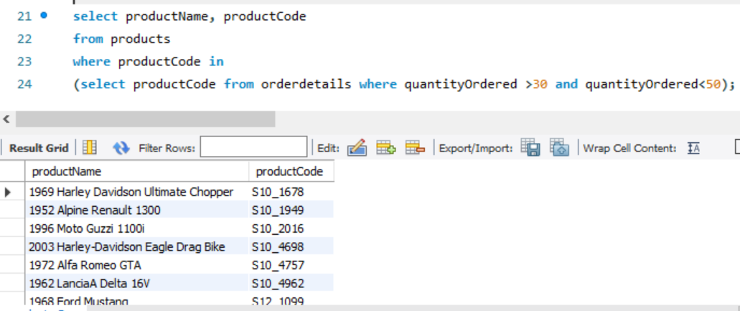

**Q:6**

select customerName

from customers

where customerNumber in(select customerNumber from orders where status="cancelled");

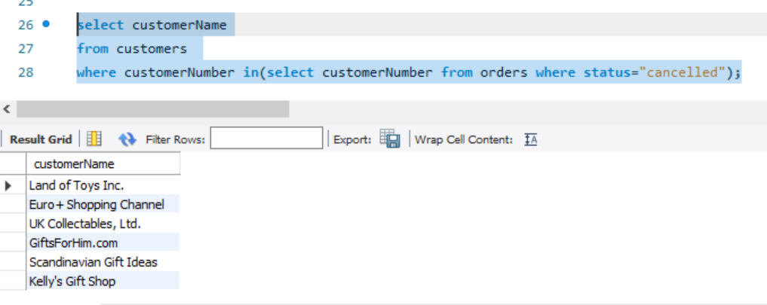

**Q:7**

select orderNumber from

orders

where orderNumber in(select orderNumber from orderdetails group by orderNumber

having sum(quantityOrdered* priceEach) >60000);

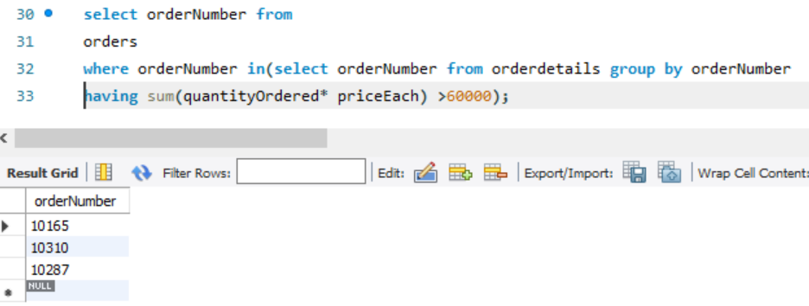

**Q:8**

SELECT DISTINCT customerNumber

FROM orders

WHERE EXISTS (

SELECT 1

FROM orderDetails

WHERE orderNumber = orderNumber

GROUP BY orderNumber

HAVING SUM(quantityOrdered * priceEach) > 60000);

